## Data Limitations Affecting Analysis Results

### ‘Suppressed’ Value for Death Rate

The data set containing information on death rates used a value of ‘suppressed’ to represent a death rate of 9 or fewer. This ‘suppressed’ value affected 80% of the data set, and when assessed by means of a graph, these values would show as zero, implying that no deaths occurred. The result was a distortion in figures which showed a much higher proportion of deaths from vulnerable older groups.

To combat this data distortion, a value of 4 was imputed in place of ‘suppressed’. It was chosen so that a death would be recorded for the region as well as the age group (as opposed to being treated as zero). Four is the median value between 0 and 9. An example of the affect this imputation had on the figures is shown in the table below:

|  |  |
| --- | --- |
| **Before Imputation**  **with ‘suppressed’ as a value** | **Following Imputation**  **where “suppressed” was replaced by 4.** |
| Delaware 2017  100% of deaths were from vulnerable populations | Delaware 2017  46.1% of deaths were from vulnerable populations |
| Utah 2017  100% of deaths were from vulnerable populations | Utah 2017  52.7% of deaths were from vulnerable populations |
| Connecticut 2016  100% of deaths were from vulnerable populations | Connecticut 2016  66.2% of deaths were from vulnerable populations |
| Hawaii 2013  100% of deaths were from vulnerable populations | Hawaii 2013  62.8% of deaths were from vulnerable populations |

Whilst this imputation helped to improve analysis outputs, it also provided too much of a pattern to the data, as can be seen in the Pivot table. The value of 1,428 is the effect of imputation.

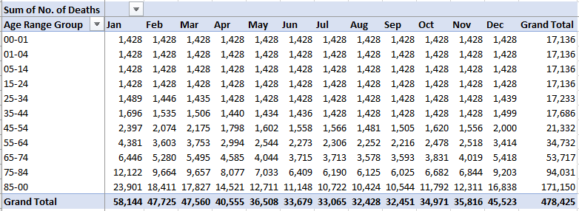

### Week Verses Month in Different Data Sets

The ideal comparison was to identify busy periods in hospitals and clinics, and compare this to the death rate to help identify any pattern or time-lag. However, it was not possible break monthly death rates in to weeks, it was only possible to convert weeks into corresponding months based on each year. This conversion was carried out although it meant the original desired comparison would be much broader making it harder to anticipate staffing needs on a weekly basis.

### Missing Data for Patient Visits in Florida

The data set containing information on the number of patient visits that were made each week in each State did not have any information available for Florida. Having identified Florida as a high priority State, and wanting to use *the number of patient visits* & the *number of patients presenting with ILI* to help predict any time-lapse or pending risk of death, it was vital that some values were provided.

Imputation was used where the average was taken per month per year to provide a value for Florida. However, it was clear that these averages were an under estimation owing to the population size of Florida, as well as their large proportion of vulnerable individuals.

## Limitations Affecting Analysis

The final slide of the Tableau storyboard shows a Word Cloud that list information that would be required to complete an effective and accurate staffing plan. The further information that each word refers to is shown below the Word Cloud.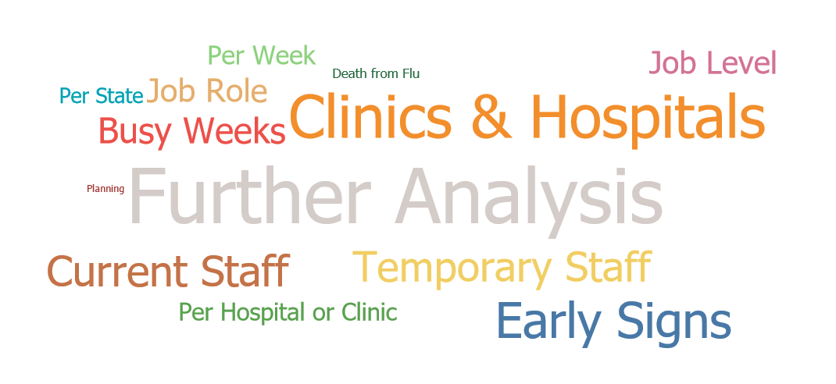

* Clinic & Hospital Which clinics and hospitals are included in the planning?
* Early Signs What indicators are there to help anticipate risk of death from flu?
* Current Staff What are the current staffing levels available?
* Temporary Staff What levels of temporary staff are available?
* Busy Weeks When are the busiest weeks in the various centres?
* Job Role What are the roles of the temporary staff?
  + - * + How many doctors, nurses, healthcare assistants, etc.
* Job Level What are the skill levels of the temporary staff?
* Per Week Staffing allocation to be made on a per week basis.
* Per Hospital or Clinic Staff to be allocated as per hospital or clinic requirements.
* Per State Staff to be allocated on a per State basis.
* Death from Flu What other factors are available to help avoid influenza related deaths?
* Planning How should the staffing plan be presented?

## Monitoring the Impact of the Staffing Plan

1. Death rates and population counts will continue to be monitored as part of government statistics. These figures help to compare the % of death rate per population but it is equally important to pay attention to volumes of numbers because the more people there are per State population, the greater the number of deaths, particularly in the case of vulnerable populations.
2. Staffing levels need to be recorded on a per week basis, and compare to patient numbers, as well as death rates:

* How many of the staff were the normal permanent staff?
* How many additional temporary staff were required?
* How many patients were suffering from ILI?
* Do we need to account for other patients requiring staffing resource?
* What was the staff to patient ratio?
* What was the severity of the illness?
* What was the resulting death rate?
* Was the department adequately staffed (or over or under)?
* Did staffing levels have an overall affect on helping to reduce death from influenza?

1. The introduction of an opinion survey for staff, patients and visitors can also help to gauge the impact of the staffing plan, and provide opinion on how well managed the department appeared.

## Tableau Storyboard

<https://public.tableau.com/profile/hannah.dilley#!/vizhome/FluSeason-AStaffingPlanAnalysis-HannahDilley/FluSeasonaStaffingPlanAnalysis?publish=yes>

## Tableau Storyboard Presentation

<https://youtu.be/fivsF0L3A2c>